ASSIGNMMET 1

ANSWER KEY

**Chapter 3:**

**P1:**

Ax= -2.5m Ay= -6.9m

**P2:**

1. h= 4.28m
2. d=11.7m

**P3:**

a)

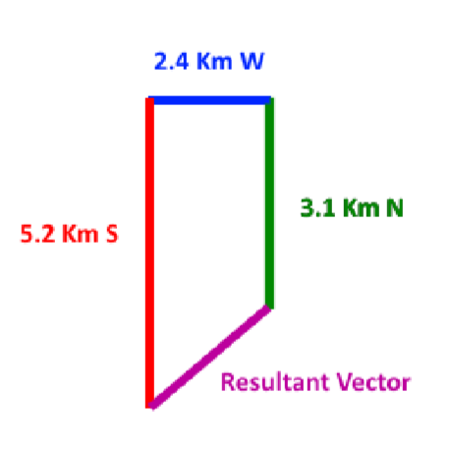

A= 3.1km j B= 2.4km i c= -5.2km j

1. |r|= 3.2 km
2. ANGLE =41°, or 221°

**P4**:

Rx= 6.32m Ry= 3.65m

**P5:**

1. The x component of rx =1.59m
2. The y component of r is ry = 12.1 m.
3. The magnitude of r is r = 12.2m
4. The angle between r and the +x direction =82.50°

**P6**:

* 1. |a ×b|=12 and the angle between them is 90.



* 1. |a ×c|=12 &

c)

|

b

⃗

×

c

⃗

|=12

The direction of

b

⃗

×

c

⃗

is



**P7:**

* 1. 47.17m
  2. Angle=58°

**P8:**

* + 1. 156.2Km
    2. Angle =129.8°or 50°

**P9:**

* 1. |a+b+c|= 38.26m ,Angle= -37.48°
  2. |a-b+c|=126.97m ~ 130m, Angle= 1.016°
  3. d= 62m, Angle= 130.40°

**P10**:

ANGLE= 70.5°

**CHAPTER 4:**

**P11:**

R0= (-2.0m)i+ (6.0m)j +( -10m)k.

**P12:**

* + 1. 1080KM
    2. -63.40° or 26.6
    3. 480km/h
    4. -63.40°
    5. 644km/h

**P13:**

* + - 1. Vavg=0.0083m/s
      2. Vavg is 0° (measured counterclockwise from the +x axis).
      3. Vavg=0.11m/s.
      4. The direction of Vavg is 297° (counterclockwise from +x) or −63°

**P14:**

* + - * 1. 56.56m
        2. 135°
        3. 1.885m/s
        4. 135°
        5. 0.471m/s^2
        6. 45° or -135°

**P15:**

The i component is the ball's horizontal velocity component. The j component of the ball is its vertical component. The vectors are added to determine the ball's velocity in two directions, essentially.

At its highest point, the ball would be neither rising nor falling, so the j component would be zero.

Since the j component is negative, the ball is falling. Thus, the ball has passed its highest point and is on the way down

**P16:**

ac= 170.2m/s^2

**P17:**

a =12.3m/s^2